**Palak Patel**

**IT 308 Project Phase 7**

**Kiosk System**

* **Projects Purpose and Business Requirements:**

We have been contracted to design a small kiosk to improve the experience for grocery shopping in stores. Users will be able to use this help as a guide menu. This will help users in multiple way like finding an item, looking for items in different brands, looking at items available in another store, etc. This system will allow its users to show the price of an item if chosen. The Kiosk System should allow an easy grocery shopping and viewing items for our users.

**Product Functionality:**

* **User Ability:**

There are two types of users for this system: the public user and the administrative user. The public user are able to login with their username and password if they already have an account. If the user doesn't have an account, they can create one by entering their personal information. The user can select the items they would like to purchase for that day and put it in a cart. They can also put the items they wish to buy in the wish list. The users are also able to see the sale items for the particular store. The user can also search for an item within the store. The user is given lots of information about the product and the other brands they search.

The administrative users are able to login with their fixed username and password. The administrative user have admin privileges. They are able to look at the items in the stores, different brands, sale items, and users. They are able to change or update any of the above attributes. If the administrative updates/deletes anything, it is also update/deleted from the database.

* **Execution:**

Once the application has started running, the user will be able to login with their username and password or they are given an option to create a new account. When creating new account, the users are asked various details about themselves like name, address, email address, phone number, username and password. After successfully logging in or creating an account, the application will ask the user if they want to search an item or see sales item. If the user searches for an item, the aisle number is presented to the user. If the item is not available at the store, the user is presented with the availability of the item at other stores as well as other brands of the product recommended by other users. If the user chooses to look at sales items, all the items on sale at the particular store is presented to the user. The users are able to add the items to their car by clicking the button "Add to Cart". The users can also add the items to their wish list by clicking the button "Add to Wish List" If the user wants to go back to the list of options, the can simply click the "Back" button. If the user wishes to exit the application, they can click the "Log Out" button. The user will be shown their cart and wish list before the application is exited. Once the user purchases those items at the register, those items are deleted and the cart or wish list is empty.

* **Explanation on why application cannot provided product functions:**

The application was unable to provide with sale items due to a reasonable price for all the items in the store. If the item is not available in the store, the application doesn't show if the item is available at another store or not. The user is not provided with this functionality is because the other store does not exist. This store is located in such a location which is a convenient location for all the shoppers. The user is not provided with the "Back" button functionality but the user is still given the choice to click the "Log Out" button on every frame after the item search.

**User Interfaces:**

* **User Interface - Expected Views of Input/Output:**
* Public User Frame

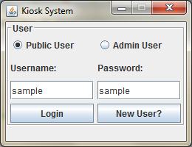

* + Item Search Screen

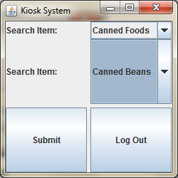

* + Item Frame

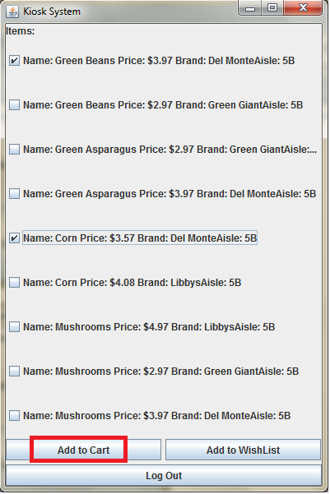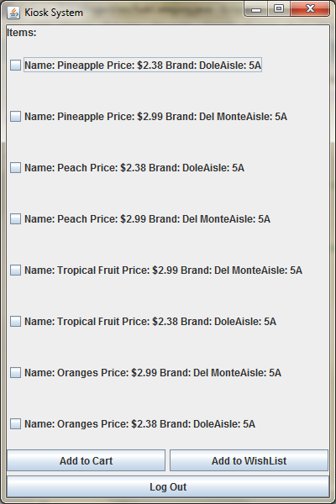

* + Admin Login Screen

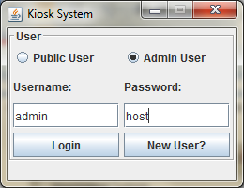

* + Admin User Frame

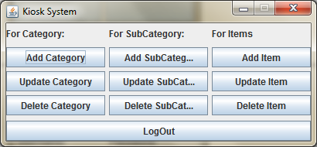

* + New User Frame

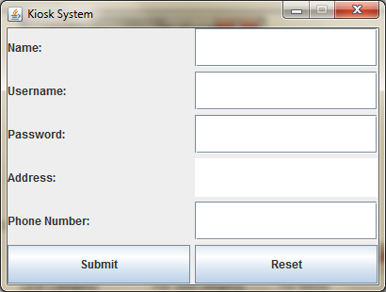

**Testing Plan:**

* **Outline of Test Plan From Phase II:**
  + **UI Items of Test Plan:**
    - The user interface items that are required in the test plan are Login, Account Creation, Search Selection, Sale View, Item Selection, Cart Information, Admin, Create Admin, and Update screens. The Login screen should be the first screen that both public and administrator users are shown which prompts them to either provide their username and password or create a new account. The Account Creation screen allows a new user to create a new account by entering a username and password. On Search Selection screen, the public user will be prompted to enter the name of the item in the search box. The Sale View screen displays the items that are on sale in that particular store. The Item Selection screen displays the item which will ask the user to select it if they want to add to the Cart or Wish List. On Cart Information screen, the public user will be shown that their item was added to the Cart. The Admin screen is same as Login screen where the administrative user will be prompted to enter their fixed credentials to access their privileges. The Create Admin screen prompts the administrative user to enter username and password to give admin privileges to another user. The Update screens allows the administrative user to select either an item or sale item which can be changed by quantity, name, price, or store-wise.
  + **Required User Input and Files:.**
    - All users are required to input username and password at the beginning of the application. If the user is new, then they must create a new account. All the user information will be store in a database. The user must enter the item they wish to search into the search box. They will be given an option to add the item to car or wish list. The administrative user can enter their fixed username and password to login. They can update information for items, users, and carts. The updated information will also change and update the database.
  + **Exceptions:**
    - ArrayOutOfBoundsException and NullPointerException will be common exception for this project, due to tons of arrays and databases used for this project. Everything will be checked in order to fix the exceptions.